Shell scripting : Variables and User Input
Fun Script: DevOps Mood Checker
Open the terminal and type nano hello .sh
Paste:
#! /bin/bash
echo "😄 Hey DevOps Warrior!"
echo "How are you feeling today? (happy/sad/confused)"
read mood
if [ "$mood" == "happy”]; then
echo "🔥 Awesome! Keep deploying success!"
elif [ "$mood" == "sad”]; then
echo "💪 Don’t worry, even servers go down sometimes!"
elif [ "$mood" == "confused”]; then
echo "🧠 That means you’re learning. Keep going!"
else
echo "🤖 Hmm... unknown mood, but you got this!"
fi
Run: chmod +x hello.sh
Then ./hello.sh
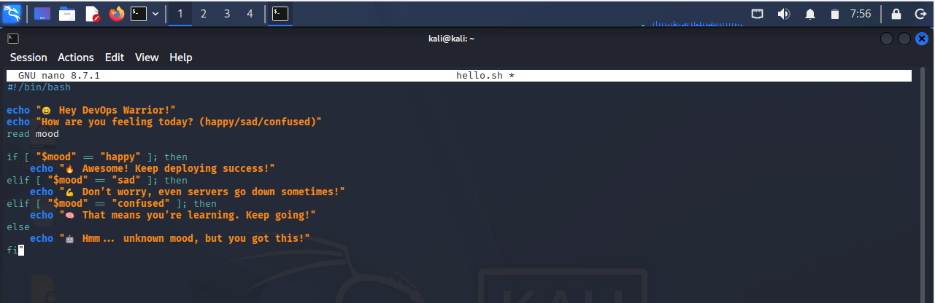
echo "...": The script speaks to you.
read name: The script listens. Whatever you type gets put inside the name box.
$name: The script opens the box. The $ symbol is the key to unlock the variable and see what is inside.
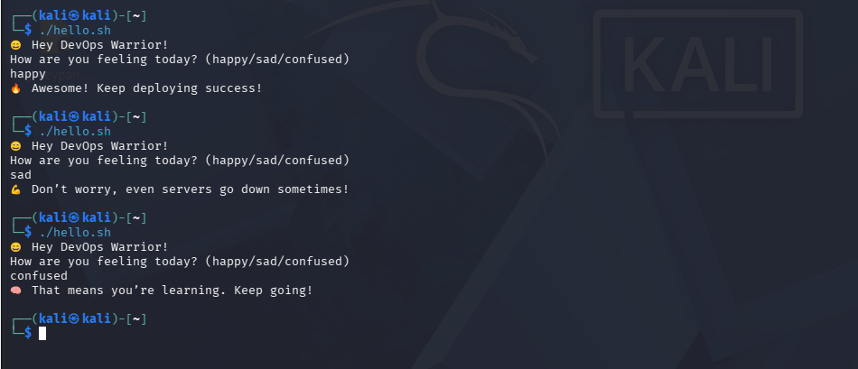
😂 2. Fun Script: “Bug or Feature?”
nano bug.sh
#!/bin/bash
echo "Did your code work? (yes/no)"
read answer
if [ "$answer" == "yes" ]; then
echo "😎 Congrats! Now don’t touch it!"
else
echo "😂 It's not a bug, it's an undocumented feature!"
fi
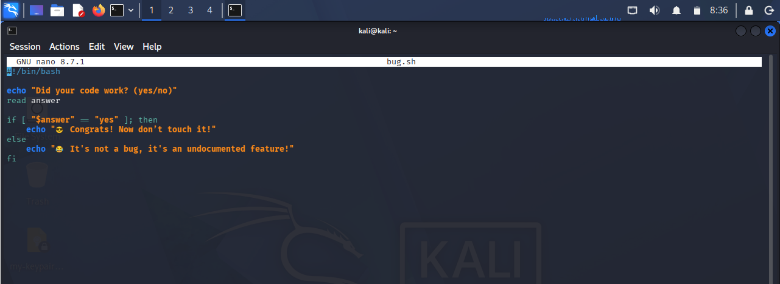
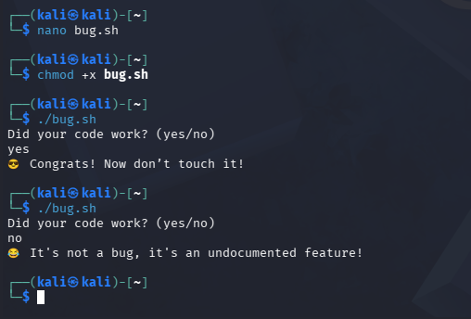
Run: chmod +x bug.sh
Then ./bug.sh
🎯 3. Practical + Fun: Username Greeting
nano user.sh
#!/bin/bash
echo "Enter your name:"
read name
echo "Welcome $name 🚀"
if [ "$name" == "Anamika" ]; then
echo "🔥 DevOps journey loading... stay consistent!"
else
echo "💡 Keep learning, $name!"
fi
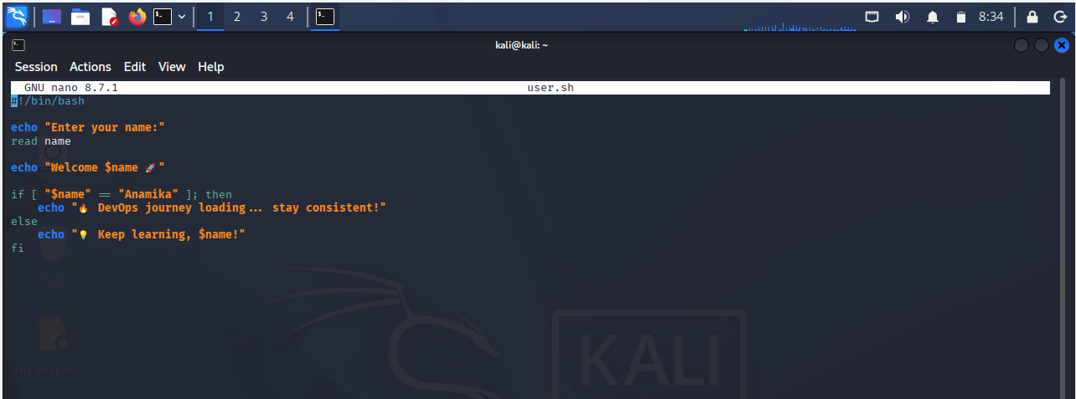
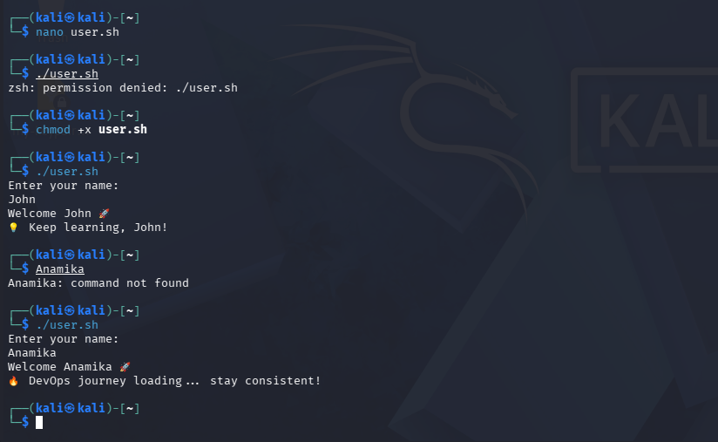
Saw what happened when I didn’t give permission and tried executing the script it said permission denied.
Running the chmod +x file.sh tells the system that "I trust this file, and I want you to allow me to run it as a program."
Run: chmod +x user.sh
Then ./user.sh

🤓 4. Log Checker (Interactive)
nano logcheck.sh
#!/bin/bash
echo "Enter log file name:"
read file
if [ ! -f "$file" ]; then
echo "❌ File not found!"
exit 1
fi
errors=$(grep -c "ERROR" "$file")
echo "Total errors in $file: $errors"
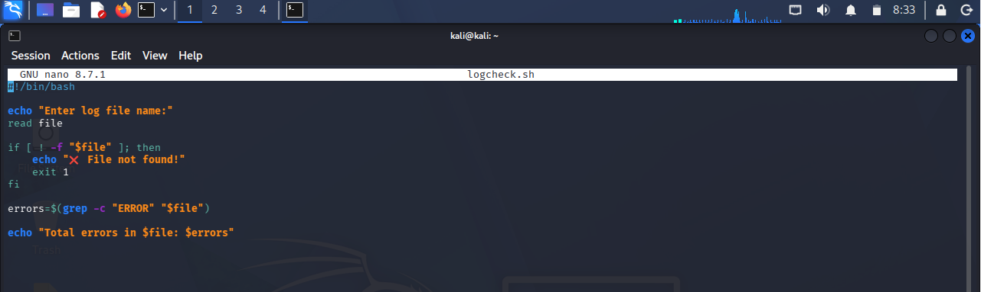

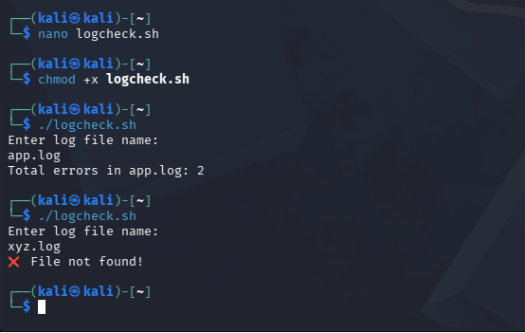
Run: chmod +x logcheck.sh
Then ./logcheck.sh

